horizontal line

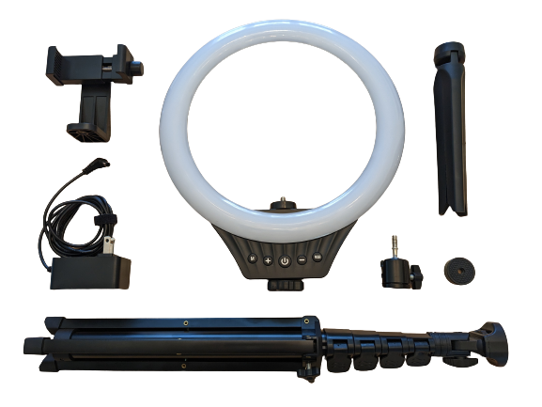

Photo Credit Kate Berg, 2023

Valusin™ 10” Desktop Ring Light

**User Manual and Quick Start Guide**

# Introduction

The Valusin™ Desktop Ring Light is a valuable addition to any home office in this new era of remote work and online meetings. Whether you are on a video call with friends or giving a presentation to your coworkers, you will enjoy the confidence boost that having good lighting provides. It offers both standard and RGB lighting options, with eight different brightness settings, allowing for an extraordinary level of control and personalization. This 10-inch ring light comes with a desktop tripod, a floor stand, and an extendable phone holder for easy use with multiple devices, such as phones, tablets, laptops, and PCs.

The purpose of this manual is to familiarize you with this product and all of its functions, and to guide you in assembly and set up. Please be sure to read the information in this manual carefully, paying special attention to the warnings and precautions before you use this product.

# Table of Contents

Introduction 1

Table of Contents 2

Warnings and Precautions 4

DANGER OF ELECTRIC SHOCK! 4

FIRE HAZARD! 4

CHOKING AND STRANGULATION HAZARD! 4

PRECAUTIONS! 5

Definitions of Key Terms 6

I. LED 6

II. RGB LED 6

III. Color Temperature (White/Natural/Warm) 6

IV. Gradient Light 6

Parts List 7

Ring Light 7

Ball Head 7

Desktop Tripod 7

Screw Pad 8

Extendable Phone Holder 8

Floor Stand 8

AC/DC Power Cord 9

Basic Button Functions 10

Assembly Guide 11

Set Up the Extendable Phone Holder (5 simple steps) 11

Set Up the Desktop Tripod (4 simple steps) 14

Set Up the Floor Stand (6 simple steps) 16

Plug in the AC/DC Adapter 19

Optional: Set Up Tripod for Phone Use Only (4 simple steps) 19

Quick Start Guide 22

How to Turn On the Ring Light: 22

How To Enter Standard Light Mode: 22

How to Enter RGB Light Mode: 22

How to Enter Automatic Gradient Mode: 22

Common Issues/Troubleshooting 22

What if the ring light does not turn on? 22

What if my floor stand keeps collapsing? 23

What if my facial features look washed out, or are difficult to distinguish? 23

What if the light is casting strange shadows on my face? 23

# Warnings and Precautions

## DANGER OF ELECTRIC SHOCK!

|  |  |
| --- | --- |
| * Do not use this product near water, on damp surfaces, or anywhere water is present. * Do not touch the power cord with wet hands. * Do not use this product if it is broken, damaged or has exposed wires. * Never attempt to insert metal objects not associated with setup into the ring light. * Only use this product indoors. |  |

## FIRE HAZARD!

|  |  |
| --- | --- |
| * The ring light will become warm while in use. * Use only as directed, on a clean, flat surface, clear of all flammable items. * Never attempt to drape anything over the ring light while in use. * Wait for the light to cool down before disassembly or storage. |  |

## CHOKING AND STRANGULATION HAZARD!

|  |  |
| --- | --- |
| * This product contains small parts that could cause choking. * This product has an electrical cord that could cause strangulation. * Keep this product away from children under 3 years old. |  |

## PRECAUTIONS!

|  |  |
| --- | --- |
| * Only use the ring light with the rated voltage and frequency: 100-240V~50/60Hz * Clean using a soft, dry cloth. * Do not try to repair the ring light. Consult a professional for repairs. |  |

# Definitions of Key Terms

## LED

LED stands for light emitting diode. These diodes glow when electricity passes through them, producing light.  
[Learn more about LED lighting here.](https://www.energystar.gov/products/lighting_fans/light_bulbs/learn_about_led_bulbs)

## RGB LED

RGB LED refers to LEDs that are red, green, and blue. RGB color refers to color that is made using different combinations of red, green, and blue light. Your Valusin™ 10” LED RGB ring light has fourteen distinct RGB LED color options, in addition to three standard lighting options.   
[Learn more about LED RGB here.](https://www.lighting.philips.com/main/support/support/faqs/white-light-and-colour/what-does-rgb-led-mean#:~:text=RGB%20LED%20means%20red%2C%20blue,formed%20by%20the%20RGB%20LEDs.)

## Color Temperature (White/Natural/Warm)

Color temperature is a way to describe the color of light given off from a light fixture. White light is associated with cool lighting, while softer, more yellow light is associated with warm lighting.   
[Learn more about color temperature here.](https://www.natalebuilders.com/blog/warm-vs-cool-lighting-what-should-you-use-in-your-home#:~:text=The%20white%20color%20refers%20to,K%20to%2010%2C000%20K%20scale.)

## Gradient Light

A smooth blending of shades from color to color.

# Parts List

|  |  |
| --- | --- |
| Image of the ring light | Ring Light **Dimensions: 10” x 12” x 1.5”**  **Weight: 278g**  The five buttons at the base of the ring light control power, light modes, and brightness. The “M” button activates standard light mode, with three color temperature options and eight brightness levels. The “RGB” button activates RGB LED mode which has fourteen light colors to choose from, and a gradient mode which rotates those colors. |
| Image of the ball head | Ball Head **Dimensions: 1.125” x 2” x 1.125”**  **Weight: 56.7g**  The ball head is able to tilt and rotate 180 degrees and is used to connect the ring light to the desktop tripod. |
| Image of the desktop tripod | Desktop Tripod **Dimensions: 2.35” x 4-9” x 2.35”**  **Weight: 60.95g** The extremely lightweight, easy to use tripod is perfect for use with a laptop or the extendable phone holder. It extends from four inches to nine inches high and has non-slip grip pads so you can be sure it will stay in place and not slide around or slip down. |
| Image of the screw pad | Screw Pad **Dimensions: 1.125” x 0.5”**  **Weight: 14.17g**  The screw pad is a padded disc used to attach the phone holder to the ring light. |
| Image of the extendable phone holder | Extendable Phone Holder **Dimensions: 4” x 3.5” x 2.25”**  **Weight: 77.96g** The extendable phone holder can be used with both the desktop tripod and the floor stand. It extends up to four inches wide and will fit most phones. It not only tilts vertically and horizontally, but also rotates 360 degrees, ensuring you can get the perfect angle in any situation. |
| Image of the floor stand | Floor Stand **Dimensions: 18” x 17-59”**  **Weight: 419.29g**  The versatile floor stand will ensure great lighting even when you are not at your desk. It can be used alone or with the extendable phone holder. It is strong, but surprisingly lightweight, and comes with non-slip grip pads on the feet. It is perfect for presentations, making videos, or photography shoots! |
| Image of the AC/DC power cord | AC/DC Power Cord **Dimensions: 68” long**  **Weight: 73.14g Voltage and frequency:** **100-240V~50/60Hz**  Having an AC/DC cord instead of a USB cord saves a port on your laptop or pc and frees up the ring light for use away from your desk with the floor stand. |

# Basic Button Functions

|  |  |
| --- | --- |
| Power Button icon. | **Power Button** Click to turn the ring light on and off. |
| Plus sign icon. | **Brightness Plus Button** Click to turn up the brightness level from 1-8. |
| Minus sign icon. | **Brightness Minus Button** Click to turn down the brightness level from 8-1. |
| A circle icon with an M in the middle. | **M “Mode” Button** Click to turn on standard light mode.  Once in standard light mode, click to rotate through white, natural, and warm light. |
| A circle icon with RGB in the middle. | **RGB Mode Button** Click to turn RGB light mode on and off.  Once in RGB light mode, click to rotate through the fourteen distinct light colors.  Click and hold for 3-5 seconds to enter gradient mode, where the ring light slowly cycles through the colors. |

# Assembly Guide

## Set Up the Extendable Phone Holder (5 simple steps)

**Note:** If you do not plan to use your ring light with the phone holder, you can skip this step and go straight to the “Set up the Desktop Tripod” or “Set up the Floor Stand” sections . You can always revisit it later.

1. **Attach the screw pad.**

Place the screw pad on the screw inside the ring light, twisting until secure.

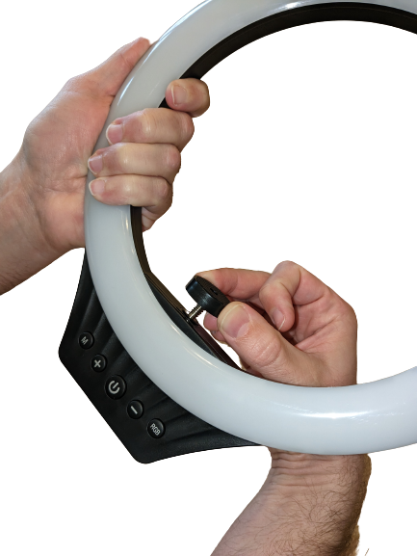

1. **Attach the extendable phone holder.**

Place the phone holder on the screw pad, twisting it until it is secure and facing the right direction. The front of the phone should face the front of the light.

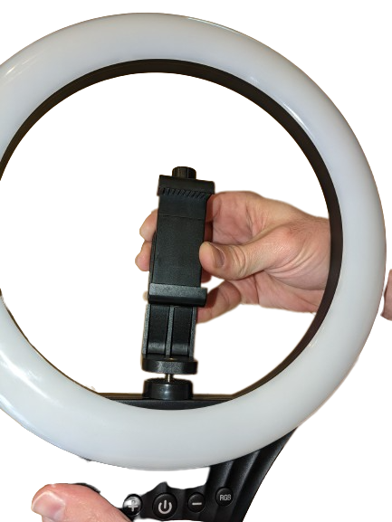

1. **Secure the phone.**

Twist the side screw on the phone holder to adjust it to the right width to secure the phone.

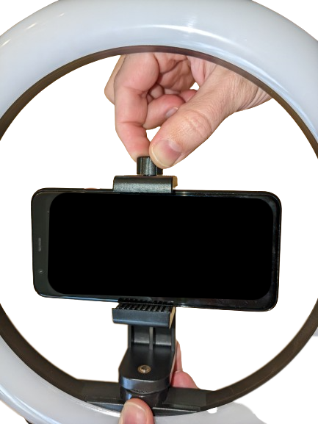

1. **Rotate the phone.**

Twist the back screw on the phone holder to rotate the phone, tightening it to secure the phone in the desired position. You can set up the phone vertically or horizontally.

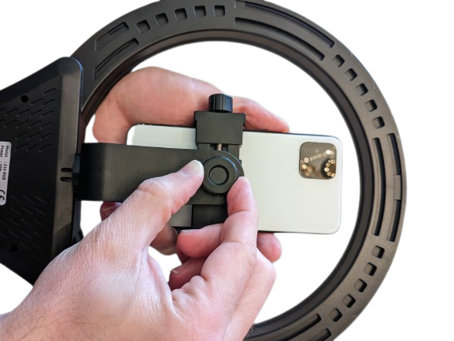

1. **Phone holder setup is complete.**

.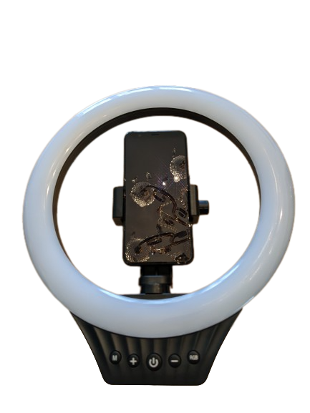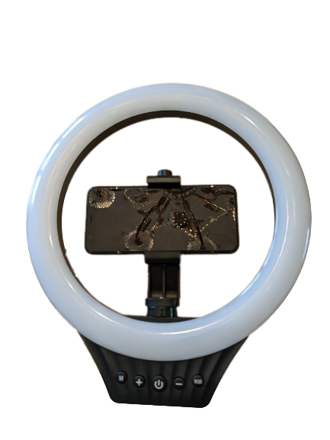

## Set Up the Desktop Tripod (4 simple steps)

1. **Attach the ball head.**

Align the ball head on the screw at the top of the desktop tripod, and twist until it becomes tight.

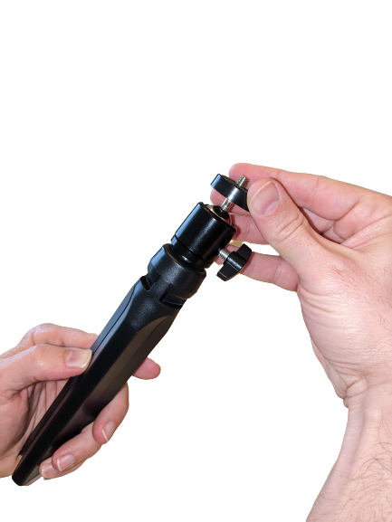

1. **Attach the ring light to the tripod.**

Align the screw on top of the tripod to the hole in the bottom of the ring light and twist until secure.

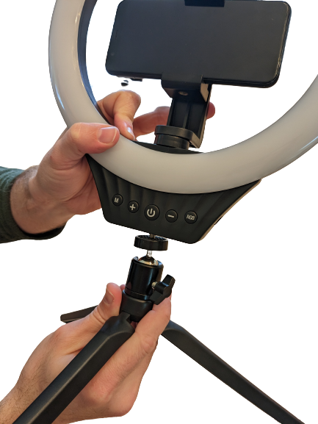

1. **Adjust the ring light using the ball head.**

Twist the screw on the side of the ball head to rotate and tilt the ring light. Tighten the screw once the ring light is in the desired position.

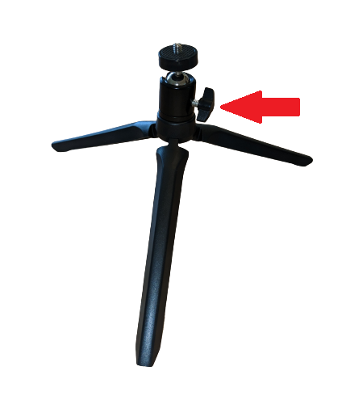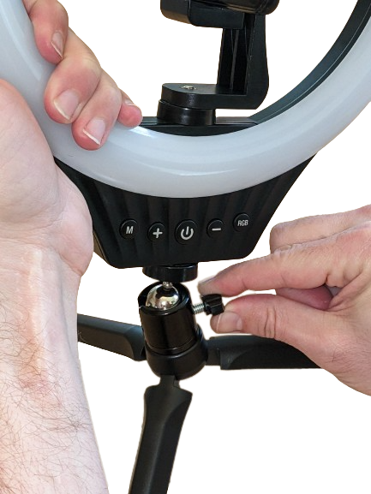

1. **Desktop tripod setup is complete.**

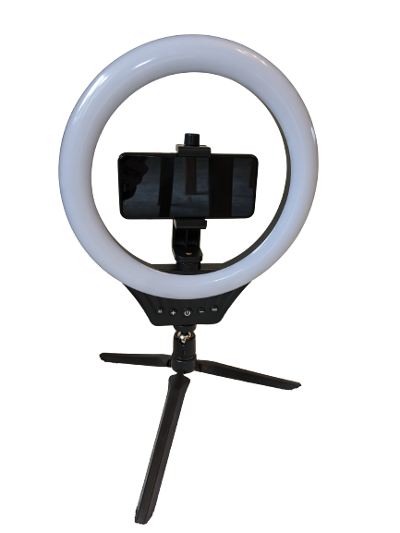

## Set Up the Floor Stand (6 simple steps)

1. **Release the base.**

Twist the lock to release the base of the tripod.

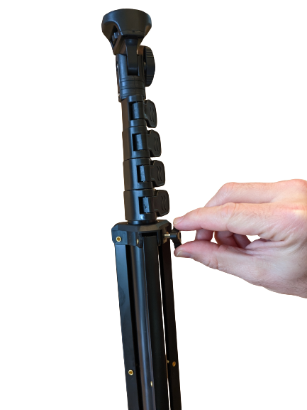

1. **Adjust and lock the base in place.**

Adjust the base to the preferred height, and then tighten the lock to secure the stand.

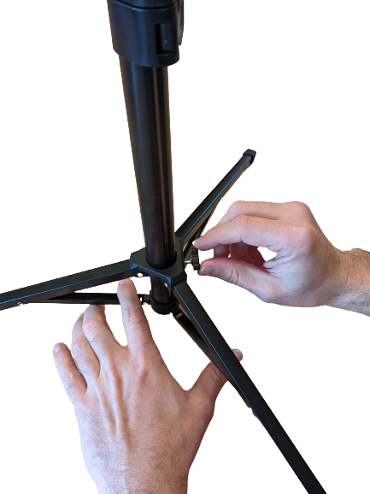

1. **Release tabs to lengthen the floor stand.**

Release the tabs to lengthen the floor stand pole to the preferred height.

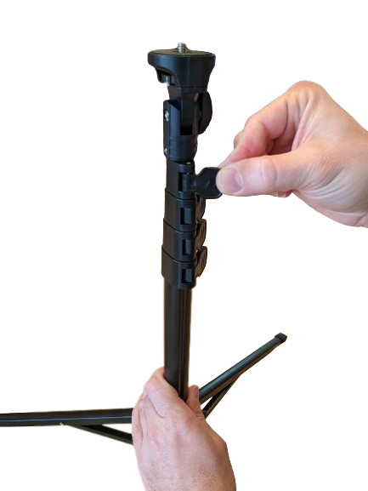

1. **Press tabs to lock the pole in place.**

Once the floor stand is at the desired height, press the tabs to lock the floor stand pole in place.

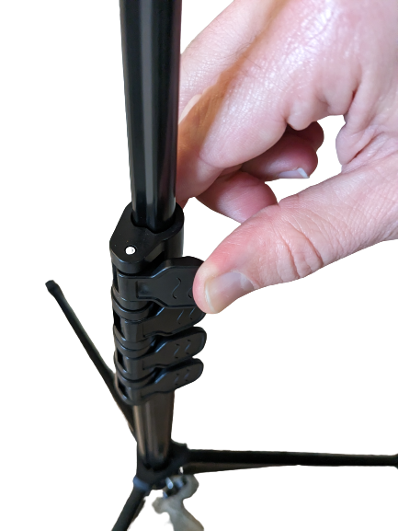

1. **Attach the ring light to the floor stand.**

Align the ring light and the screw on top of the floor stand, then twist until it becomes tight. (You can also turn the gear at the top of the floor stand to tighten the screw.)

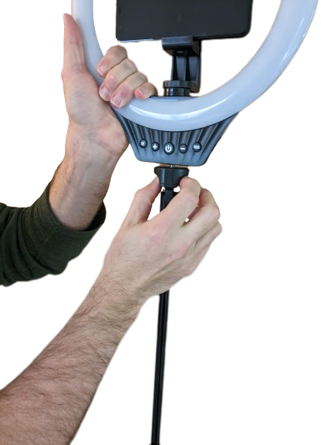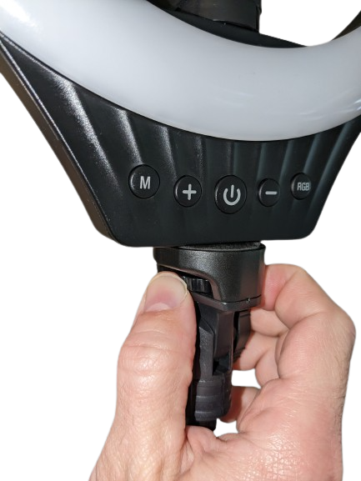

1. **Floor stand setup is complete.**

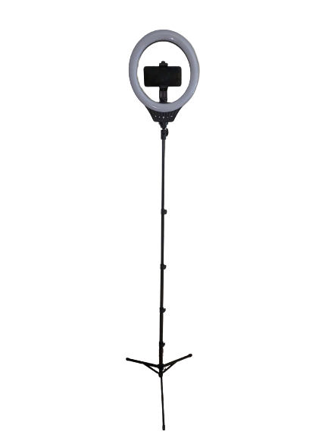

## Plug in the AC/DC Adapter

Once you have set up your ring light with the preferred configuration, you can plug in the AC/DC adapter as shown.

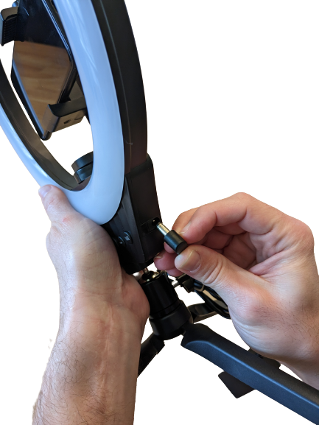

## Optional: Set Up Tripod for Phone Use Only (4 simple steps)

**Note:** The desktop tripod can be used with the phone holder directly, without attaching the ring light. This bonus functionality could come in handy if you want to use the ring light with the floor stand but set up your phone somewhere else.

1. **Attach the ball head.**

Align the ball head on the screw at the top of the desktop tripod, and twist until it becomes tight.



1. **Attach extendable phone holder to tripod.**

Align the phone holder with the screw pad on top of the tripod and twist until secure.

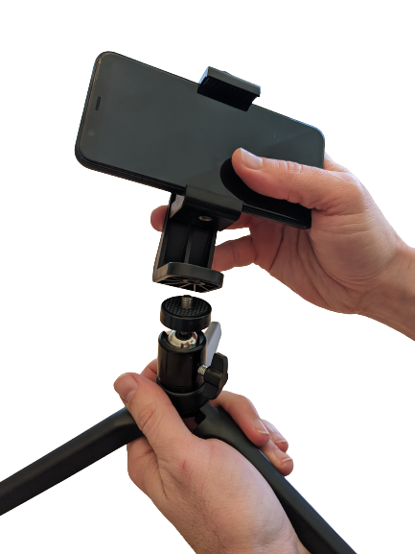

1. **Adjust the phone holder using the ball head.**

Twist the screw on the side of the ball head to rotate and tilt the phone holder. Tighten the screw once the phone holder is in the desired position.

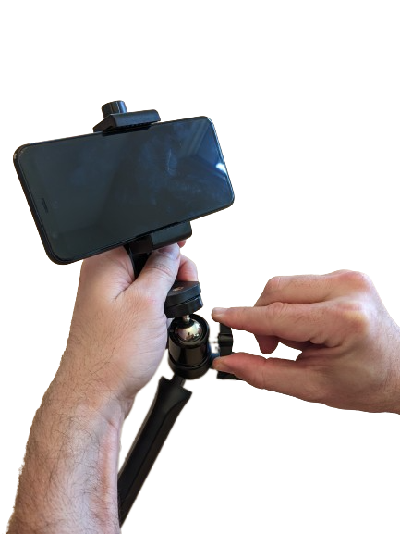

1. **Phone holder with tripod setup is complete.**

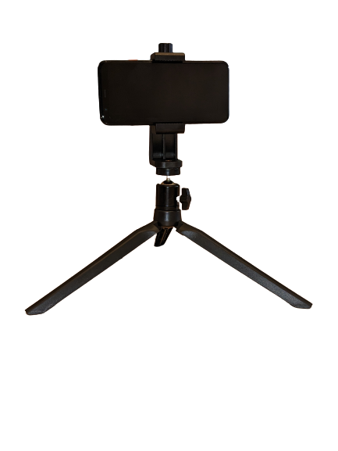

# Quick Start Guide

## How to Turn On the Ring Light:

* Press the power button to turn on the ring light. The ring light will automatically enter the light mode you were using the last time you turned it off.

## How To Enter Standard Light Mode:

* Press the “M” button to enter standard light mode and to cycle through the white, warm, and natural light options. You can then adjust the brightness levels by pressing either the plus or minus buttons.

## How to Enter RGB Light Mode:

* Press and hold the “RGB” button for 3-5 seconds, and the ring light will enter gradient mode. The color will slowly cycle from red, yellow, green, light blue, blue, purple, and pink. Press the “M” button to return to standard mode.

## How to Enter Automatic Gradient Mode:

* Press the “RGB” button to enter RGB mode, and to cycle through the fourteen distinct colors that are available. You cannot adjust the brightness levels while in RGB mode.

# Common Issues/Troubleshooting

## What if the ring light does not turn on?

* Make sure the ring light is plugged in. Check that the AC/DC adapter is plugged securely into the ring light, and the cord is plugged into an electrical outlet. See the assembly guide for the correct place to plug in the adapter.
* Make sure the electrical outlet you are using has power. You can do this by plugging in another device, like a lamp, or your phone charger, and checking that there is power going to that device.

## What if my floor stand keeps collapsing?

* If your floor stand keeps collapsing, make sure all four of the extender tabs are pressed in and locked in place. See the assembly guide for how to secure the tabs.
* Also, make sure the base of the floor stand is locked in place by ensuring the screw at the bottom is tight. See the assembly guide for how to adjust and lock the base.

## What if my facial features look washed out, or are difficult to distinguish?

* Usually, if your facial features look too washed out, or are difficult to distinguish, it is because the light is too bright. Try adjusting the brightness using the plus and minus buttons.
* Additionally, if your facial features still seem too washed out, you can try placing the ring light farther away from your face.

## What if the light is casting strange shadows on my face?

* For the best results, the ring light should be placed at face level. If the ring light is too high or too low, or too far to one side or the other, shadows will naturally be cast on the part of your face farthest away from the light.
* Strange shadows might also be caused by the angle of the ring light. See the assembly guide for information about adjusting the forward, backward and side tilt of the ring light.